**Exp no: 6 JavaScript forms and Validations**

**Aim:**

To practice with basic javascript forms and validation of the form fields.

**Description:**

Forms are used in webpages for the user to enter their required details that are further send it to the server for processing. The data entered into a form needs to be in the right format and submitted fields need to be validated.

For Example:

Username, password, contact information are some details that are mandatory in forms and thus need to be provided by the user.

HTML is used to create the form and JavaScript is to validate the form.

**Algorithm:**

Forms starts and ends with <form> tag. Syntax is

<form action=”” method =”” name = “”>

</form>

Javascript function is used to validating form fields. Syntax for function:

function *name*(*parameter1, parameter2, parameter3*)

{

// *code to be executed*

}

**Application:**

Travel and Tourism (IRCTC Train ticket booking).

**Sample input:**

A form for booking ticket in IRCTC webpage.

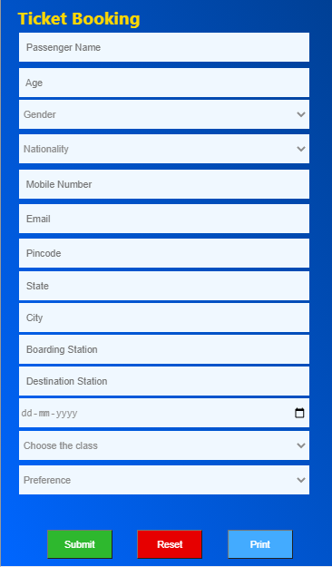

**Sample Output:**

Passenger name validation:

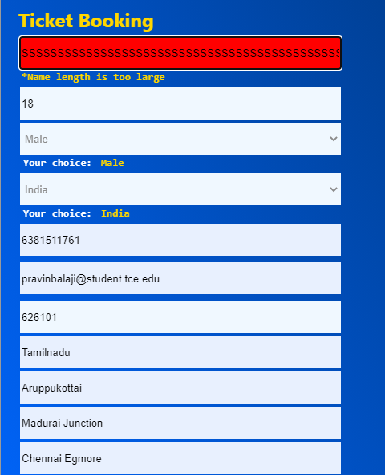

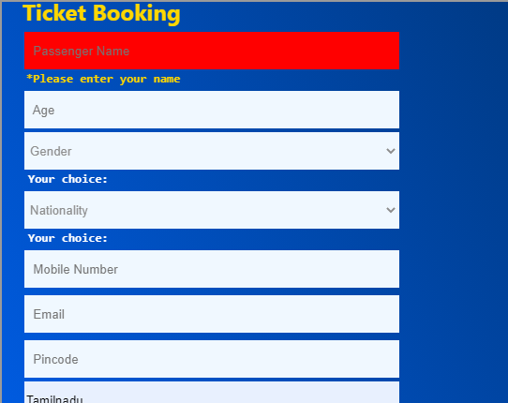

Phone number validation:

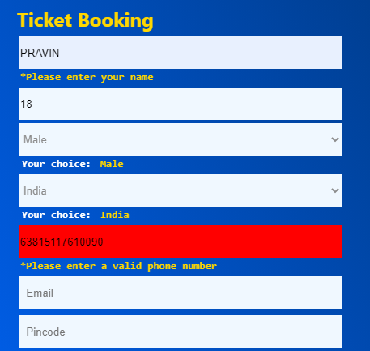



Email validation:

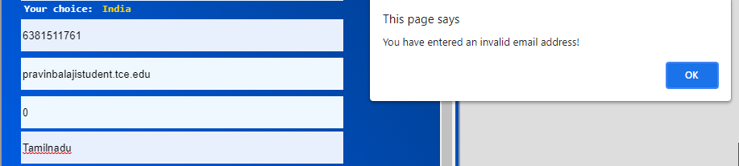

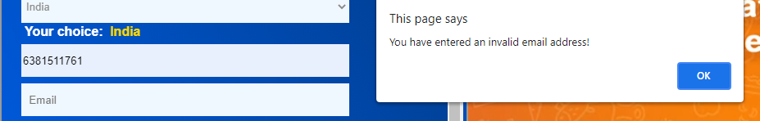

**Result:**

Thus, the webpage that contains forms have been validated using Javascript form validation.